1. Is your browser running HTTP version 1.0 or 1.1? What version of HTTP is the

server running? 1.1

2. What languages (if any) does your browser indicate that it can accept to the

server? En-us

3. What is the IP address of your computer? Of the gaia.cs.umass.edu server? 10.0.0.82

4. What is the status code returned from the server to your browser? 200

5. When was the HTML file that you are retrieving last modified at the server? Mon, 11 Oct 2021 05:59:02

6. How many bytes of content are being returned to your browser? 128

7. By inspecting the raw data in the packet content window, do you see any headers

within the data that are not displayed in the packet-listing window? If so, name

one. No

8. Inspect the contents of the first HTTP GET request from your browser to the

server. Do you see an “IF-MODIFIED-SINCE” line in the HTTP GET? Yes

9. Inspect the contents of the server response. Did the server explicitly return the

contents of the file? How can you tell? No return the file was not modified

10. Now inspect the contents of the second HTTP GET request from your browser to

the server. Do you see an “IF-MODIFIED-SINCE:” line in the HTTP GET? If

so, what information follows the “IF-MODIFIED-SINCE:” header? Yes, Tue, 12 Oct 2021.

11. What is the HTTP status code and phrase returned from the server in response to

this second HTTP GET? Did the server explicitly return the contents of the file?

Explain. 304 Not Modified no return

12. How many HTTP GET request messages did your browser send? Which packet

number in the trace contains the GET message for the Bill or Rights? 1, packet 25

13. Which packet number in the trace contains the status code and phrase associated

with the response to the HTTP GET request? 21

14. What is the status code and phrase in the response? 200 ok

15. How many data-containing TCP segments were needed to carry the single HTTP

response and the text of the Bill of Rights? 3 21,22,24

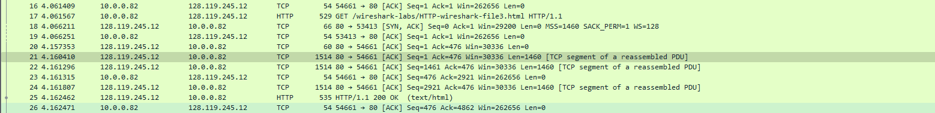

16. How many HTTP GET request messages did your browser send? To which

Internet addresses were these GET requests sent? 3, two sent to ip address 128.119.245.12 and 1 sent to 178.79.137.164

17. Can you tell whether your browser downloaded the two images serially, or

whether they were downloaded from the two web sites in parallel? Explain. Seriel, one after the other according to the time.

18. What is the server’s response (status code and phrase) in response to the initial

HTTP GET message from your browser? 401 Unauthorized

19. When your browser’s sends the HTTP GET message for the second time, what

new field is included in the HTTP GET message? Authorization basic